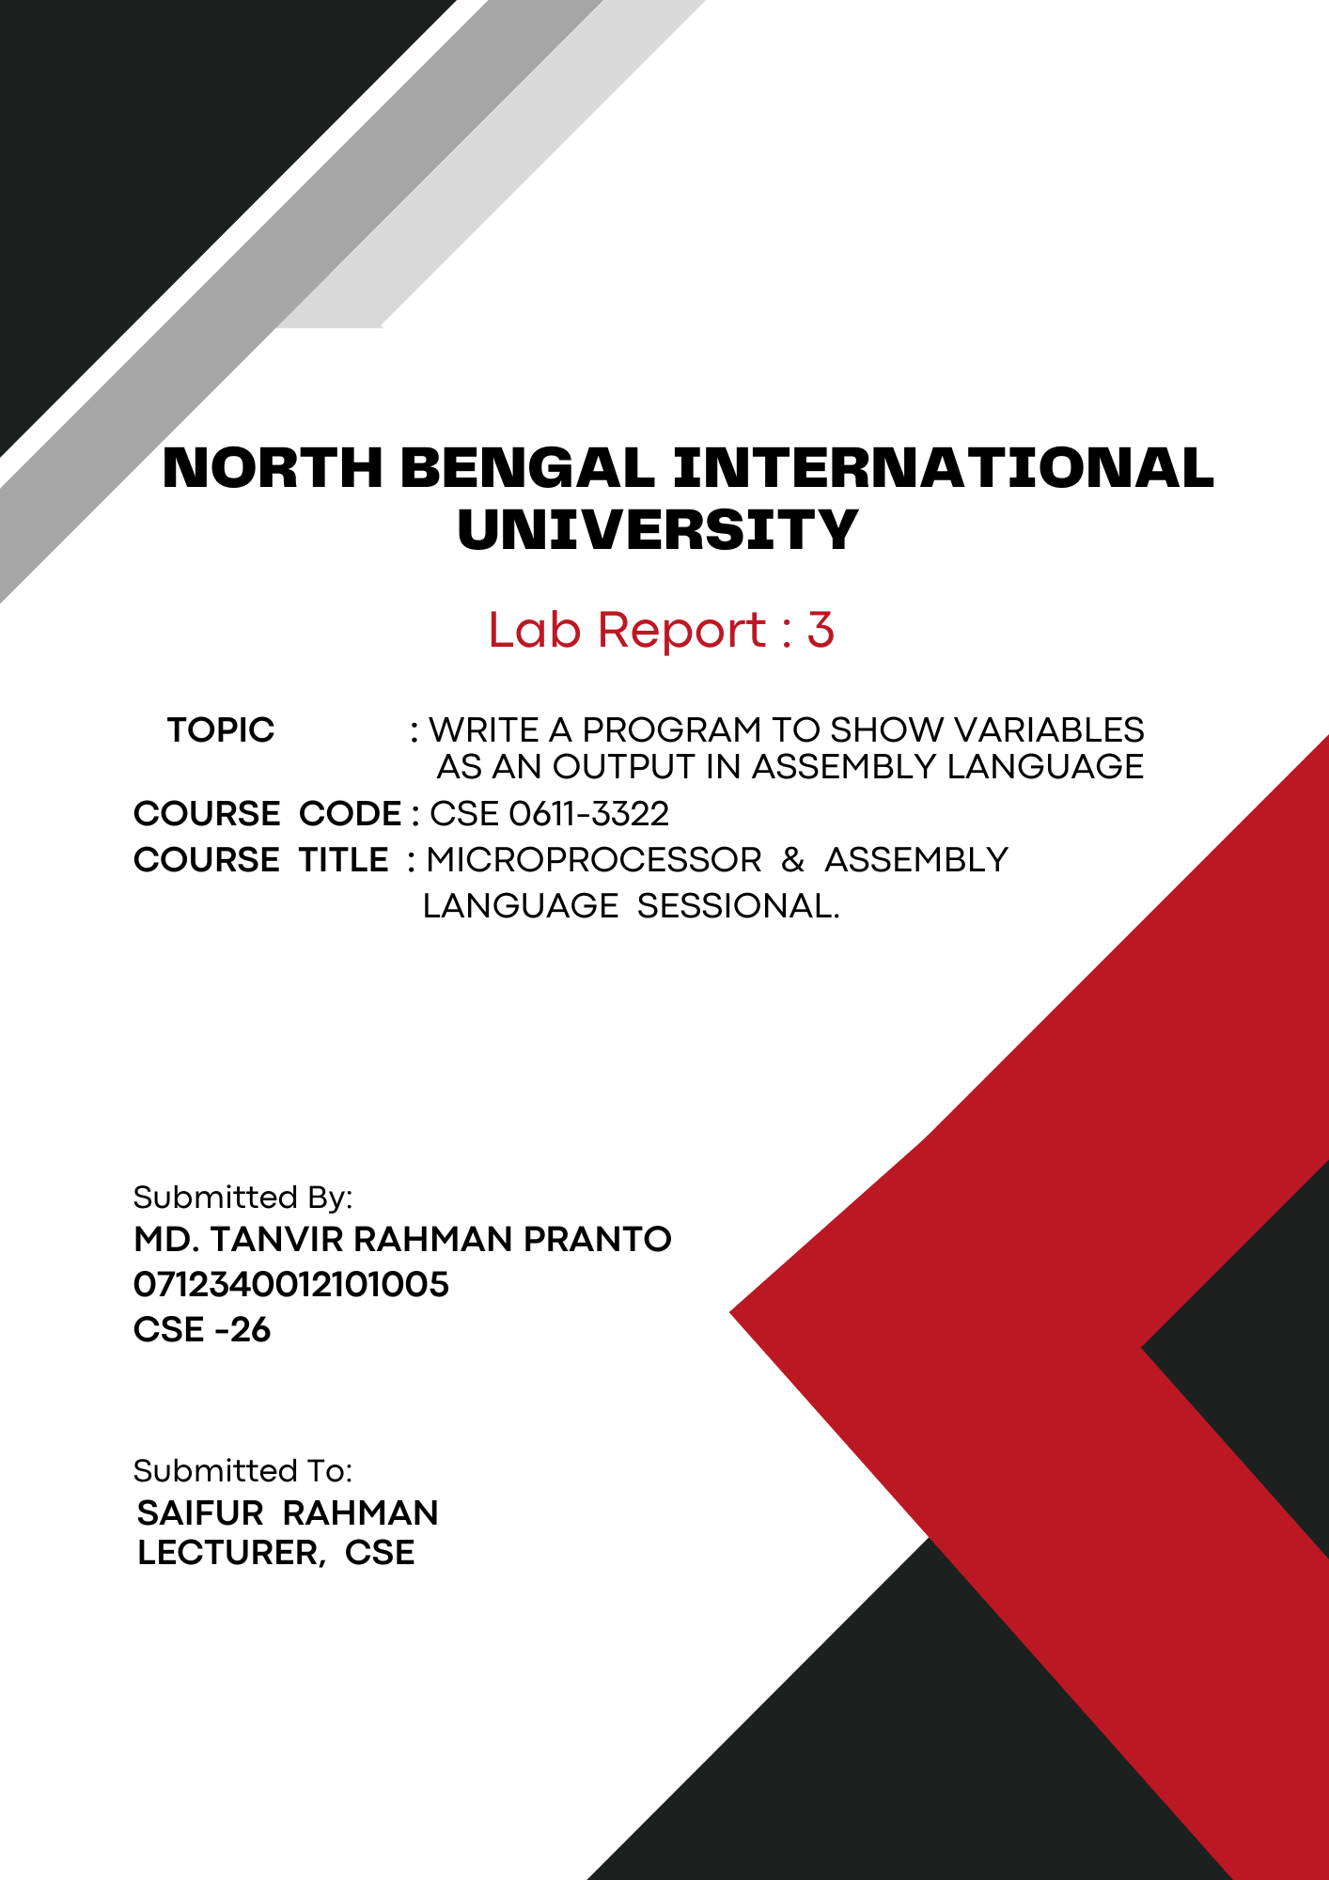
1

Theory: Assembly language is a low-level programming language that's more readable than machine language. It uses symbolic names instead of binary code, making it easier to understand and write. Each instruction corresponds to a specific machine language instruction and is specific to a particular computer architecture. It's often used for tasks needing high performance or direct hardware control.

Show Variable Output in Assembly Language:
This assembly language program defines two variables, var1 and var2. It sets up the data segment and displays the value of var1, followed by a newline. It then converts var2 to its ASCII equivalent and displays it.

Code:

.model small
.stack 100h

.data
var1 db 't' ; Define a variable with the value 't'
var2 db 3 ; Define a variable with the value 3

.code
main proc
; Initialize the data segment
mov ax, @data
mov ds, ax

; Display var1
mov ah, 2
mov dl, var1
int 21h

; Print a newline (Line Feed and Carriage Return)
mov ah, 2
mov dl, 10
int 21h
mov dl, 13
int 21h

; Convert var2 to ASCII and display it
mov ah, 2
add var2, 48 ; Convert integer to ASCII character
mov dl, var2
int 21h

exit:
; Exit program
mov ah, 4ch
int 21h
main endp
end main

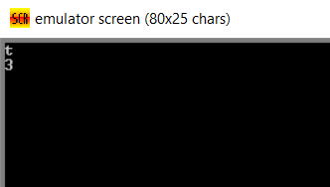
Output:

Conclusion: This assembly language program defines two variables and displays their values using DOS interrupts. It includes handling for newline and carriage return characters to format the output. The program exits cleanly after displaying the values.

